Unit #: 1
Unit Name: Problem solving fundamentals
Topic: Introduction to C and C Features

Course objectives:
The objective(s) of this course is to make students
CObj1: Acquire knowledge on how to solve relevant and logical problems using computing machine
CObj2: Map algorithmic solutions to relevant features of C programming language constructs
CObj3: Gain knowledge about C constructs and it's associated eco-system
CObj4: Appreciate and gain knowledge about the issues with C Standards and it's respective behaviors
CObj5: Get insights about testing and debugging C Programs

Course outcomes:
At the end of the course, the student will be able to
CO1: Understand and apply algorithmic solutions to counting problems using appropriate C Constructs
CO2: Understand, analyse and apply text processing and string manipulation methods using C Arrays, Pointers and functions
CO3: Understand prioritized scheduling and implement the same using C structures
CO4: Understand and apply sorting techniques using advanced C contructs
CO5: Understand and evaluate portable programming techniques using preprocessor directives and conditional compilation of C Programs

Let us answer few questions before we start with C.

Q1. What is a Computer Programming Language (CPL)?
- Any set of rules that converts strings, or graphical program elements in the case of visual programming languages, to various kinds of machine code output.
- A CPL is an artificial language that can be used to control the behaviour of a machine, particularly a computer.

- CPLs, like human languages, are defined through the use of syntactic and semantic rules, to determine structure and meaning respectively.
- CPLs are used to implement algorithms.
- CPLs allow us to give instructions to a computer in a language the computer understands.
- Formal computer language or constructed language designed to communicate instructions to a machine, particularly a computer (wiki definition).
- Can be used to create programs to control the behaviour of a machine.

Q2. Why CPL?

Advance our ability to develop real algorithms.

Majority of CPLs come with a lot of features for the Computer Programmers - CP.

CPLs can be used in a proper way to get the best results.

Improve Customization of our Current Coding.

By using basic features of the existing CPL we can simplify things to program a better option to write resourceful codes.

There is no compulsion of writing code in a specific way, but rather is the usage of features used and clarity of the concept.

Q3. Why so many Programming Languages?
To choose the right language for a given problem. Example Domains are listed – Web Browsers, Social Networks, Image Viewer, Facebook.com, Bing, Google.com, Games, Various Operating Systems

Q4. What are the different Levels of Programming Language?
- Low Level
  - Binary codes which CPU executes
  - Programmer’s responsibility is more
  - Machine Language
- Middle Level
  - Offers basic data structure and array definition, but the programmers should take care of the operations
  - C and C++
- High Level
  - Programmer concentrates on the algorithm and programming itself
  - Java , Python, Pascal

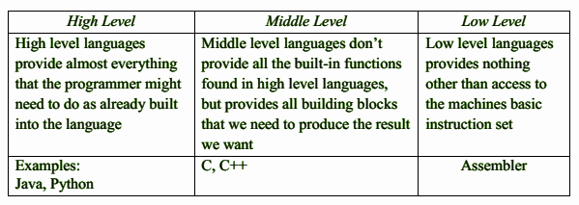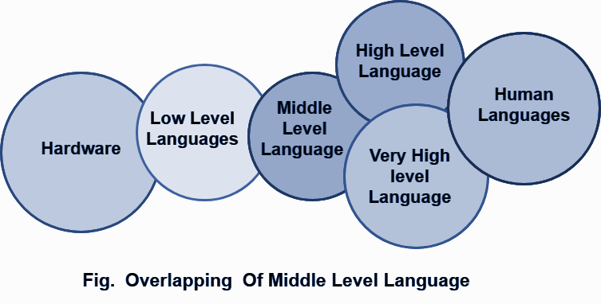

Q5. What is the meaning of Paradigm?

A programming paradigm is a style, or “way,” of programming. Some languages make it easy to write in some paradigms but not all of them
Imperative: Programming with an explicit sequence of commands that update state –
Example: python
Declarative: Programming by specifying the result you want, not how to get it
Example: LISP, SQL
Structured: Programming with clean, goto-free, nested control structures
Example: C Language
Procedural: Imperative programming with procedure calls
Example: C Language.
Functional (Applicative): Programming with function calls that avoid any global state Examples: Scheme, Haskell, Miranda and JavaScript.
Function-Level (Combinator): Programming with no variables at all
Examples: Scheme, Haskell, Miranda and JavaScript.
Object-Oriented: Programming by defining objects that send messages to each other. Objects have their own internal (encapsulated) state and public interfaces.
Class-based: Objects get state and behavior based on membership in a class.
Prototype-based: Objects get behavior from a prototype object.
Examples: Java, C++, Python
Event-Driven: Programming with emitters and listeners of asynchronous actions.
Flow-Driven: Programming processes communicating with each other over predefined channels.
Logic (Rule-based): Programming by specifying a set of facts and rules. An engine infers the answers to questions.
Constraint: Programming by specifying a set of constraints. An engine finds the values that meet the constraints.
Aspect-Oriented: Programming cross-cutting concerns applied transparently.
Reflective: Programming by manipulating the program elements themselves.
Array: Programming with powerful array operators that usually make loops unnecessary.

Q6: Which Languages are used while Developing Whatsapp? Think. !

Erlang, JqGrid, Libphonenum, LightOpenId, PHP5, Yaws and many more…

Q7. Why should one learn C? What are the advantages of ‘C’? Is not ‘C’ an outdated language?

We have to fill our stomach every day 3 or 4 times so that our brain and body get enough energy to function. How about eating Vidyarthi Bhavan Dosa every day? What about Fridays when the eatery is closed? Why not buy Dosa batter from some nearby shop? Or do you prefer to make the batter yourself? Would you have time to do that? Would that depend on how deep your pockets are? Would you like to decrease your medical bills?


Every language has a philosophy. The language used by poets may not be suitable for conversation. Poets use ambiguity in meaning to their advantage, and some verses in Sanskrit have more than one meaning. But that will not be suitable for writing a technical report. The goal of ‘C’ is efficiency. The safety is in the hands of the programmer. ‘C’ does very little apart from what the programmer has asked for.

Example: When we index outside the bounds of a list in Python, we get an “index error” at runtime. To support this feature, Python runtime should know the current size of a list and should also check whether the index is valid each time we index on a list. You are all very good programmers, and I am sure you never get an index error. You get what you deserve. If you are lucky, the program crashes. Otherwise, something subtle may happen, which later may lead to catastrophic failures.
    - C gives importance to efficiency
    - C is not very safe; you can make your program safe
    - C is not very strongly typed; mixing of types may not result in errors
    - C is the language of choice for all hardware related softwares
    - C is the language of choice for software’s like operating system, compilers, linkers, loaders, device drivers.

Q8. Is ‘C’ not an old language?
Yes and No.
It was designed by Dennis Ritchie –We use ‘C’ like languages and Unix like operating systems both have his contribution – in 70s. But the language has evolved over a period. The latest ‘C’ was revised in 2011.
There is one more reason to learn ‘C’. ‘C’ is the second most popular language as of now according to TIOBE index ratings. https://www.tiobe.com/tiobe-index/.

Q9. What is TIOBE Index?

The Importance Of Being Earnest” - TIOBE.

TIOBE is an indicator of the popularity of programming languages.

The TIOBE index is updated once a month.

The ratings are based on the number of skilled engineers world-wide, courses and third party vendors.

Popular search engines such as Google, Bing, Yahoo!, Wikipedia, Amazon, YouTube and Bing are used

It is not about the best programming language or the language in which most lines of code have been written.
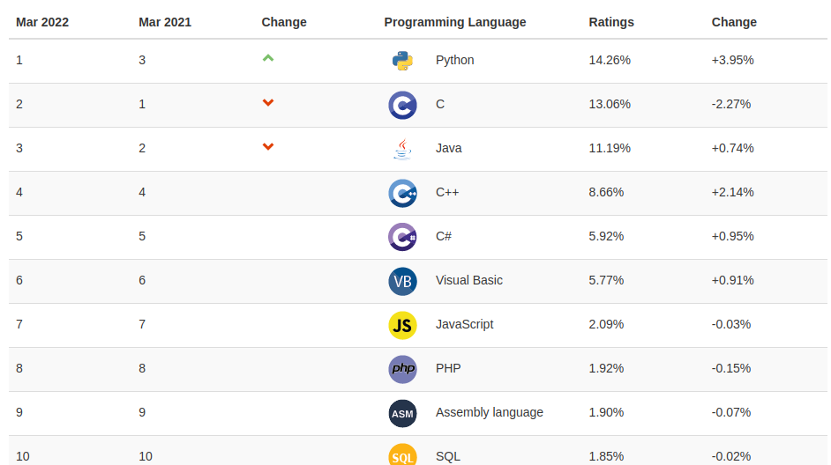

Q10: What is the history of PLs?

1820-1850 England, Charles Babbage invented two mechanical Computational device i.e., Analytical Engine and Difference Engine

In 1942, United States, ENIAC used electrical signals instead of physical motion

In 1945, Von Newman developed two concepts: Shared program technique and Conditional control transfer

In 1949, Short code appeared

In 1951, Grace Hopper wrote first compiler, A-0

Fortran: 1957, John Backus designed.

Lisp, Algol- 1958

Cobol: 1959

Pascal: 1968, Niklaus Wirth

C: 1972, D Ritchie

C++: 1983, Bjarne Stroustrup, Compile time type checking, templates are used.

Java: 1995, J. Gosling, Rich set of APIs and portable across platform through the use of JVM

Development of C

Martin Richards, around 60’s developed BCPL [Basic Combined Programming Language]

Enhanced by Ken Thompson and Introduced B language.

C is originally developed between 1969 and 1973 at Bell Labs by Dennis Ritchie and Kernighan. Closely tied to the development of the Unix operating system

Standardized by the ANSI [American National Standards Institute] since 1989 and subsequently by ISO [International Organization for Standardization].

ANSI C, C89, C99, C11, C17, or C2x

Introduction to C

Let us discuss the applications of C before digging into C.

Operating Systems: A high-level programming language built in the C programming language was used to construct the first operating system, which was UNIX. Later on, the C programming language was used to write Microsoft Windows and several Android apps. Symbian OS is used in cellular phones.

GUI (Graphical User Interface): Since the beginning of time, Adobe Photoshop has been one of the most widely used picture editors. It was created entirely with the aid of the C programming language. Furthermore, C was used to develop Adobe Illustrator and Adobe Premiere.

Embedded Systems and mechatronic systems with hardware interfaces: Because it is directly related to the machine hardware, C programming is often regarded as the best choice for scripting programs and drivers for embedded systems, among other things.

Mozilla: Internet Browser Firefox Uses C++.

Bloomberg: Provides real time financial information to investors

Callas Software: Supports PDF creation, optimization, updation tools and plugins

Features of C Language

Simple and Efficient:
The basic syntax style of implementing C language is very simple and easy to learn. This makes the language easily comprehensible and enables a programmer to redesign or create a new application. C is usually used as an introductory language to introduce programming to school students because of this feature.

Fast:
It is a well-known fact that statically typed programming languages are faster than dynamic ones. C is a statically typed programming language, which gives it an edge over other dynamic language. Also, unlike Java and Python, which are interpreter-based, C is a compiler-based program. This makes the compilation and execution of codes faster. Another factor that makes C fast is the availability of only the essential and required features. Newer programming languages come with
numerous features, which increase functionality but reduce efficiency and speed. Since C offers limited but essential features, the headache of processing these features reduces, resulting in increased speed.

Portability:
Another feature of the C language is portability. To put it simply, C programs are machine-independent which means that you can run the fraction of a code created in C on various machines with none or some machine-specific changes. Hence, it provides the functionality of using a single code on multiple systems depending on the requirement.

Extensibility:
You can easily (and quickly) extend a C program. This means that if a code is already written, you can add new features to it with a few alterations. Basically, it allows adding new features, functionalities, and operations to an existing C program.

Function-Rich Libraries:
C comes with an extensive set of libraries with several built-in functions that make the life of a programmer easy. Even a beginner can easily code using these built-in functions. You can also create your user-defined functions and add them to C libraries. The availability of such a vast scope of functions and operations allows a programmer to build a vast array of programs and applications.

Dynamic Memory Management:
One of the most significant features of C language is its support for dynamic memory management (DMA). It means that you can utilize and manage the size of the data structure in C during runtime. C also provides several predefined functions to work with memory allocation. For instance, you can use the free () function to free up the allocated memory at any time. Similarly, there are other functions such as malloc (), calloc (), and realloc () to perform operations on data structure and memory allocations.

Modularity with Structured Language:
C is a general-purpose structured language. This feature of C language allows you to break a code into different parts using functions which can be stored in the form of libraries for future use and reusability. Structuring the code using functions increases the visual appeal and makes the program more organized and less prone to errors.
Mid-Level Programming Language:
Although C was initially developed to do only low-level programming, it now also supports the features and functionalities of high-level programming, making it a mid-level language. And as a mid-level programming language, it provides the best of both worlds. For instance, C allows direct manipulation of hardware, which high-level programming languages do not offer.

Pointers:
With the use of pointers in C, you can directly interact with memory. As the name suggests, pointers point to a specific location in the memory and interact directly with it. Using the C pointers, you can operate with memory, arrays, functions, and structures.

Recursion:
C language provides the feature of recursion. Recursion means that you can create a function that can call itself multiple times until a given condition is true, just like the loops. Recursion in C programming provides the functionality of code reusability and backtracking.

We will start exploring C Constructs in the upcoming lecture notes by solving some of the interesting Problems!
Happy Coding!

